**Assignment 3**

1. **write a SQL query to find Employees who have the biggest salary in their Department.**

select isnull(E.emp_name,'No employee') as [Name], isnull(E.dept_id,0) as [Employee ID], isnull(E.salary, 0) as [Salary] from department D left join employee E on D.dept_id = E.dept_id

where E.salary in (

select max(salary) from department d

left join employee e on d.dept_id = e.dept_id

group by e.dept_id) or e.salary is null

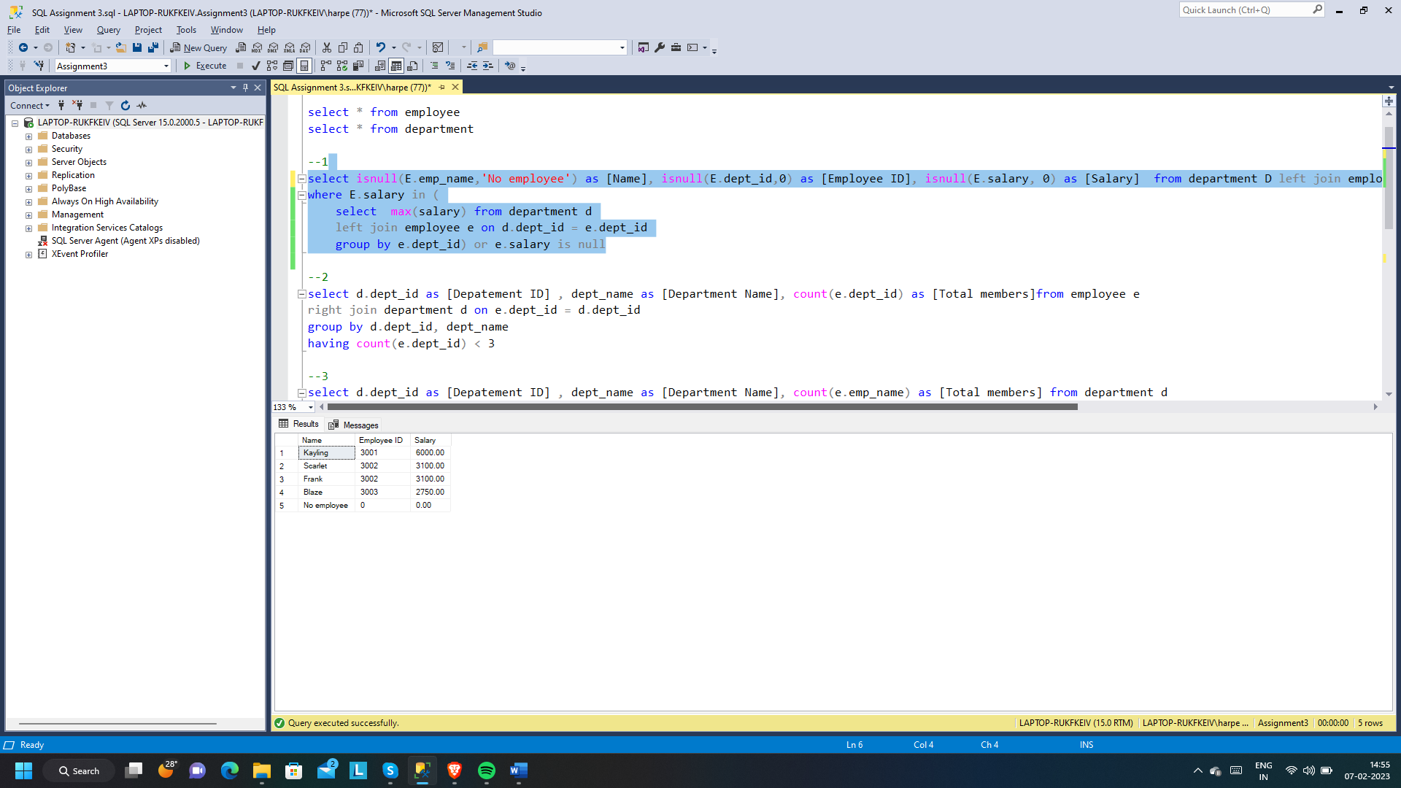

1. **write a SQL query to find Departments that have less than 3 people in it.**

select d.dept_id as [Depatement ID] , dept_name as [Department Name], count(e.dept_id) as [Total members]from employee e

right join department d on e.dept_id = d.dept_id

group by d.dept_id, dept_name

having count(e.dept_id) < 3

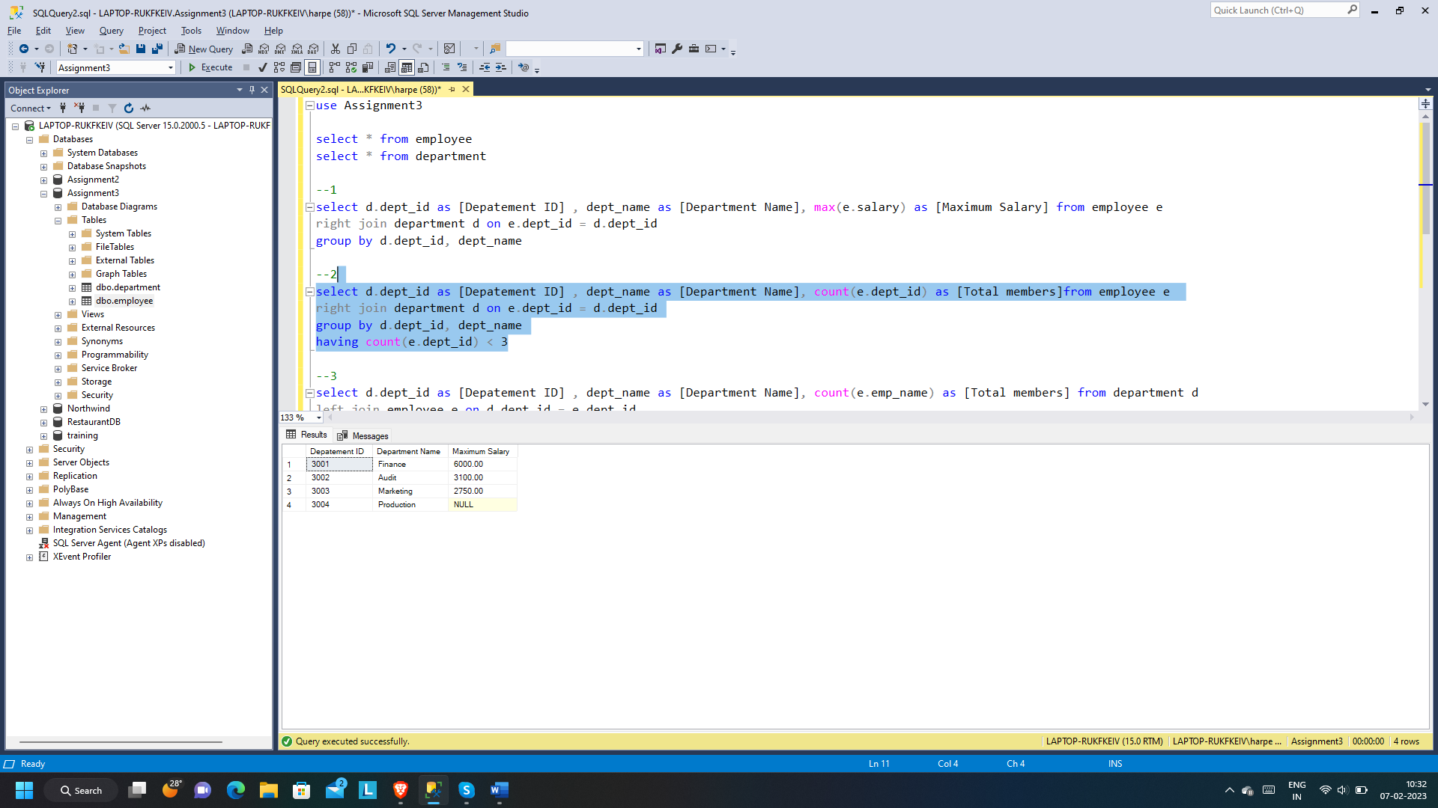

1. **write a SQL query to find All Department along with the number of people there.**

select d.dept_id as [Depatement ID] , dept_name as [Department Name], count(e.emp_name) as [Total members] from department d

left join employee e on d.dept_id = e.dept_id

group by d.dept_id, dept_name

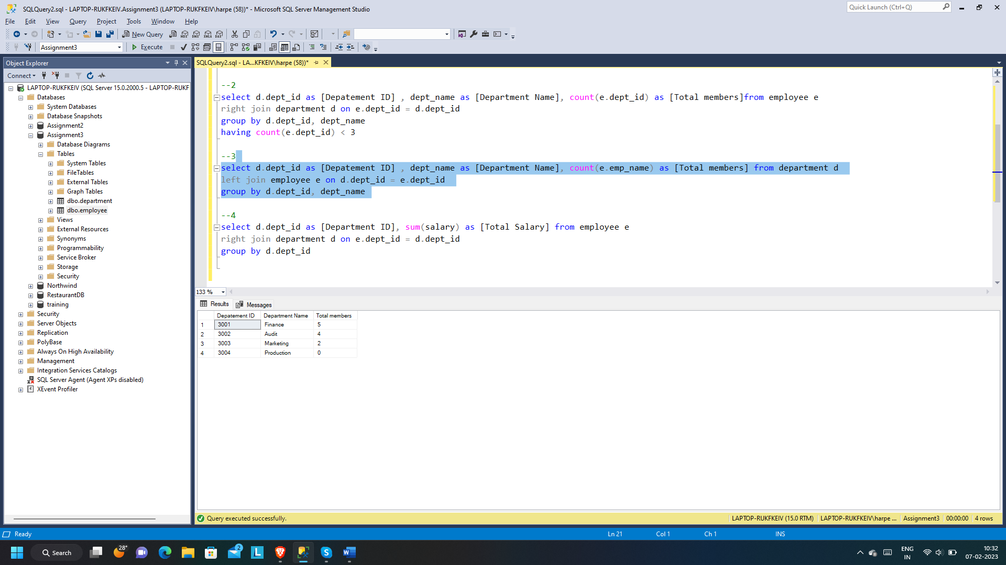

1. **write a SQL query to find All Department along with the total salary there.**

select d.dept_id as [Department ID], sum(salary) as [Total Salary] from employee e

right join department d on e.dept_id = d.dept_id

group by d.dept_id

